

Gearing calculation test plan

Propulsion system simulation

Fangzhou chen Jiacong li Marco Hoogesteger Martijn Crombeen

*Organisation: Solar Boat Sealander*

*Client: Mr. R. Eijlers*

*Tutor: Mr. W. Haak*

*Date: 21-12-2020*

2020

Table of content

1. Aim & Hypothesis 2

1.1. Aim 2

1.2. Hypothesis 2

2. Variables 2

2.1. Inputs 2

2.2. Outputs 2

3. Tools 3

4. Method 3

4.1 Steps 3

5.Expect result 3

6.Conclusion 3

7.Appendix 3

7.1 gear friction power loss 3

7.1.1 Friction force 3

7.1.2 Relative velocity 4

7.2 Gear churning loss 4

# Aim & Hypothesis

## Aim

The aim of this test is to establish a mathematical model of gear energy loss.

## Hypothesis

Power, speed and torque after passing through the gear can be calculated by the input value.

# Variables

These are the constants and variables that will be used during the test.

|  |  |
| --- | --- |
| Constants simulation | Keep constant at... |
| Ambient temperature | Standard indoor temperature with lower and upper limits (20 ℃ ± 5℃). |
| Battery level computer | Constant power source. |
| All input variables | Real positive numbers & ISO-notation. |

## Inputs

The limits stated are the limits of the real world. If values out of this range are entered, the outputs will be unreliable.

|  |  |
| --- | --- |
| General input | Value |
| Gear friction coefficient(a) | 0.2 |
| Gear transmission ratio | 3 |
| Gear index circle pressure angle(l) | 30 |
| Gear index circle diameter of driving wheel(d) | 0.3 |
| Gear addendum radius(e) | 0.32 |
| Gear dedendum radius(f) | 0.28 |
| Gear tooth number(z) | 15 |
| Gear tooth width ratio(b) | 0.2 |
| Gear modulus(m) | 2 |
| Gear immersion depth ratio(h) | 0.4 |
| Gear lubricant viscosity (u) | 2 |
| Gear lubricant density(p) | 4 |

|  |  |
| --- | --- |
| Inputs for realistic calculation | Value |
| Motor power output | [0,8800] [w] |
| Motor torque output | [0,40] [Nm] |
| Motor rotation speed ouput | [0,2400] [rpm] |

|  |  |
| --- | --- |
| Inputs for theoretical calculation | Value |
| Feedback rotation speed from propeller | - |
| Feedback torque from propeller | - |

## Outputs

These are the outputs that will be monitored and will be used to see variations or changes in the system.

|  |  |
| --- | --- |
| Outputs from realistic calculation | Value |
| Gearing power output | [0,8800] [w] |
| Gearing torque output | [0,40] [Nm] |
| Gearing rotation speed ouput | [0,2400] [rpm] |

|  |  |
| --- | --- |
| Outputs from theoretical calculation | Value |
| Feedback rotation speed to motor | - |
| Feedback torque to motor | - |
| Gearing power loss | - |

# Tools

|  |  |
| --- | --- |
| Testing tools | Demand |
| Computer | Windows 10 compatible |
| Excel | Newest version |
| Keyboard | No limit |
| Mouse | No limit |
| Calculator | Basic calculator |
| Pen & Paper | Basic pen & paper |
| Mathematical model | Consists of formulas |

# Method

## 4.1 Realistic calculation

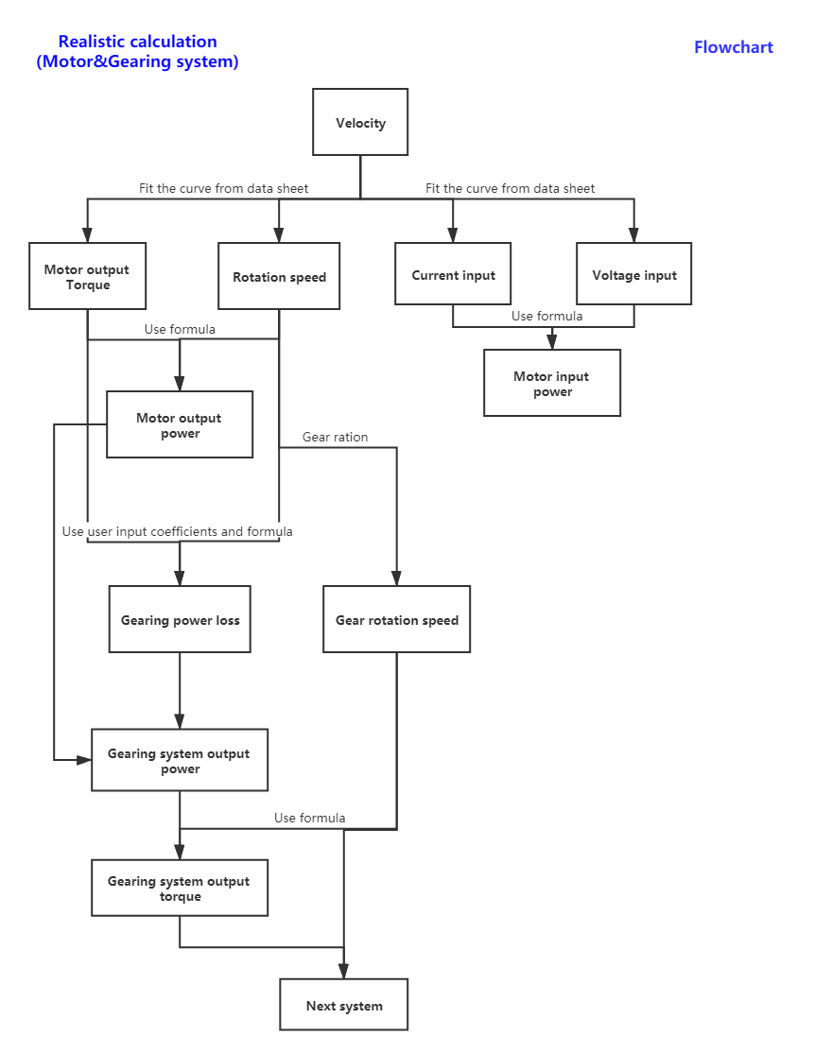

The gear part is inside the red frame.

## 4.2 Theoretical calculation

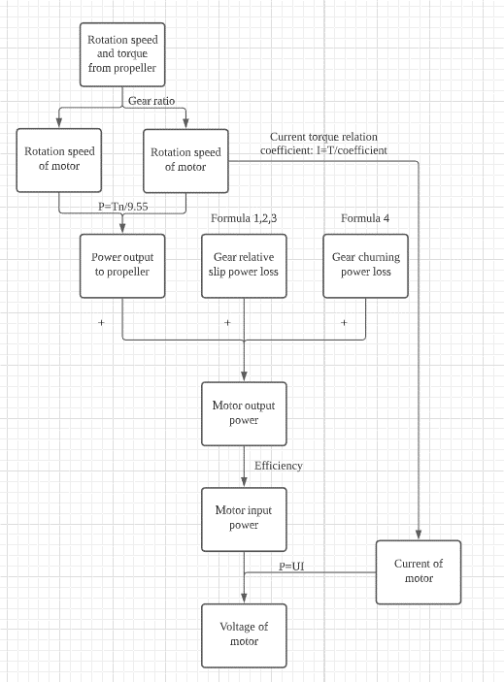

## 4.3 Theoretical calculation

When inputting the speed of the ship, compare the motor input and output voltage and current calculated by fitting the curve with the theoretically calculated motor input and output voltage and current. If the error is less than 30%, the digital twin is considered to be successfully established and the fitted curve is used in subsequent calculations. Since the process output value of the gear system is difficult to compare, the output value of the motor system is used as the comparison standard.

## 4.4 Steps

* Get the input torque and speed from the motor part.
* Calculate energy loss and rotation speed.
* Calculate output torque from energy loss and speed.
* Record the energy loss and the output speed and torque of the gear system.
* In the theoretical calculation part, input the torque and speed fed back from the propeller to the gear.
* Calculate the speed and speed of the gear feedback to the motor.
* Verify the above calculations’ results by paper and pen.
* The success of the verification of the gear system determines the success or failure of the verification of the motor system. Since the gear system and the motor system are closely connected, the verification of the gear system and the motor system will be combined.

# 6.Expect result

When power, speed, and torque are transferred from the motor component system to the gear component system, the output power, speed, and torque of the gear system can be calculated according to the set parameters. The gear calculation system can use the data to correctly calculate the result.

# 7.Conclusion

If the outputs have the same values as their calculated counterparts, the test is considered as passed. If not, the test is considered as failed.

# 8.Appendix

The energy loss on the gear consists of the meshing between the gears and the gear churning loss. In the gear component, the loss of these two parts will be calculated.

## 8.1 gear friction power loss

$$P_{VZP}=F_{R}×V_{rel}$$

$P_{VZP}$ = load gear losses (kW).

$F_{R}$ =friction force (kN).

$V_{rel}$ =relative velocity (m/s).

### 8.1.1 Friction force

$$F_{R}=F_{n}×μ_{M}$$

$F_{n}$ =Normal force of tooth surface[N].

$μ_{M}$ =Friction coefficient.

$$F_{n}=\frac{F_{t}}{cosα}$$

$$F_{t}=\frac{2T}{d}$$

$F_{t}$ =Gear circumferential force [N].

$α$ =Index circle pressure angle, standard gear is ${ 20}^{°}$.

T=Torque [N*m].

d=Index circle diameter of driving wheel [m].

### 8.1.2 Relative velocity

The sliding speed is the relative speed of the common contact point between the paired gear teeth in the transverse plane. (Gear Rolling & Sliding velocity) The sliding speed can be approximated as

$$V_{rel}=\frac{(d_{1}+d_{2})}{2}×ω×2×cosα$$

$d_{1}$ =Addendum radius[m].

$d_{2}$ =Deddendum radius[m].

$ω$ = Angular velocity[rad/s].

$α$ =Index circle pressure angle, standard gear is ${ 20}^{°}$.

## 8.2 Gear churning loss

Because of lubricate, the gear will face resistance when it is rotating, resulting in energy loss.

$$P_{loss}=1.177m^{0.0214}×z^{0.0106}×ρd^{5}×{(\frac{1}{Re})}^{0.34}{(\frac{1}{Fr})}^{0.61}{(\frac{h}{d})}^{0.35}{(\frac{b}{d})}^{1.21}$$

$$Fr=\frac{ωd}{g}$$

$$Re=\frac{ρR^{2}ω}{μ}$$

$m$ =Modulus.

$z$ =Number of teeth.

$ρ$ =Lubricant density[${kg}/{m^{3}}$].

d=Index circle diameter of driving wheel [m].

$ω$ =Rotation speed[rpm].

$g$ =9.8 $[N/{m^{2}}]$.

$μ$ = Lubricant viscosity.

$\frac{h}{d}$ = Gear immersion depth ratio [0.2 $\sim$ 1].

$\frac{b}{R}$ = Tooth width ratio $[0.2\sim 1]$.

## 8.3 Gear type

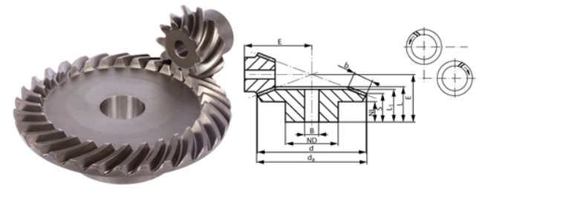

Figure 1 Gear

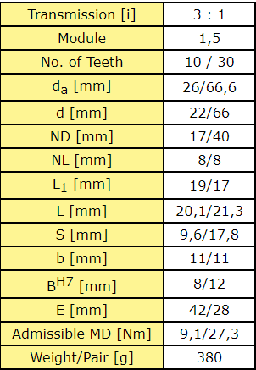

Figure 2 Gear size parameters